Final Assessment

1. Given the schema below, where primary keys are underlined, write the following queries in SQL:

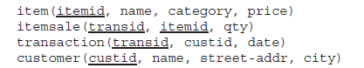

1. Find the name and price of the most expensive item (if more than one item is the most expensive, print them all)
2. Print the total sales (in terms of units and total price) of every item category in every customer-city
3. Find items with no sales at all to customers in Mumbai
4. Find customers who bought the same quantity of the same item on subsequent dates.
5. Find all customers who did not buy any item in category “Electronics”
6. Consider the insurance database of Figure 1. Where the primary keys are underlined. Construct the following SQL queries for this relational database.
   1. Find the total number of people who owned cars that were involved in accidents in 2009.
   2. Add a new accident to the database; assume any values for required attributes.
   3. Delete the Mazda belonging to “John Smith”.
   4. Find the number of accidents in which the cars belonging to “John Smith” were involved.
   5. Update the damage amount for the car with license number “AABB2000” in the accident with report number “AR2197” to $3000.

